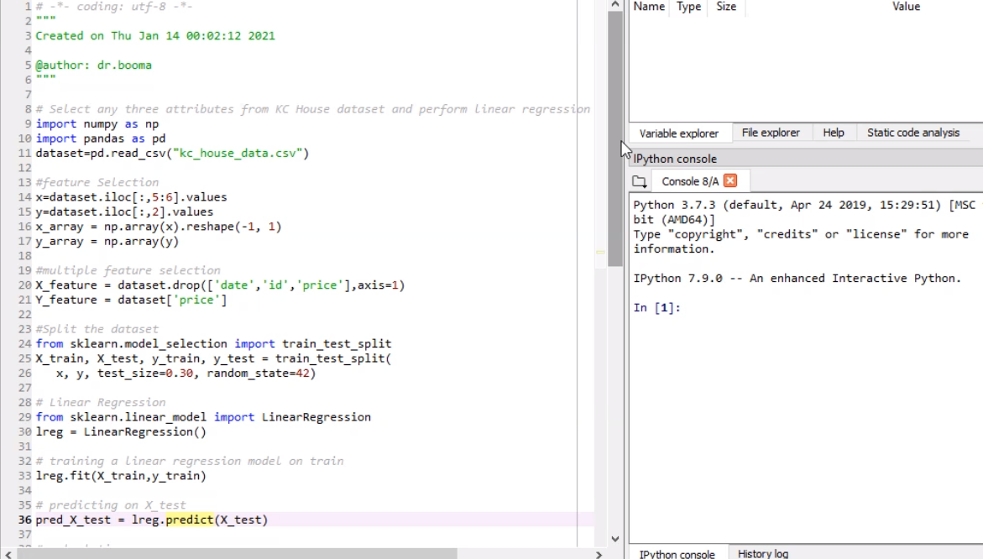

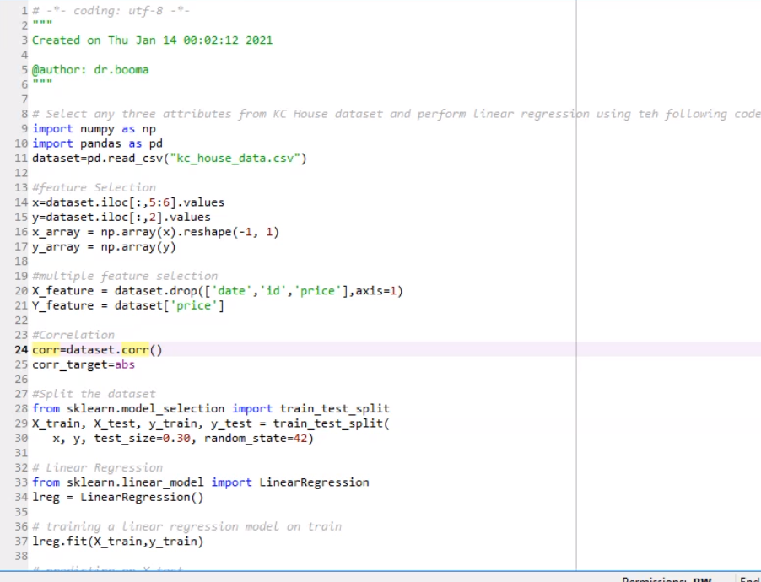

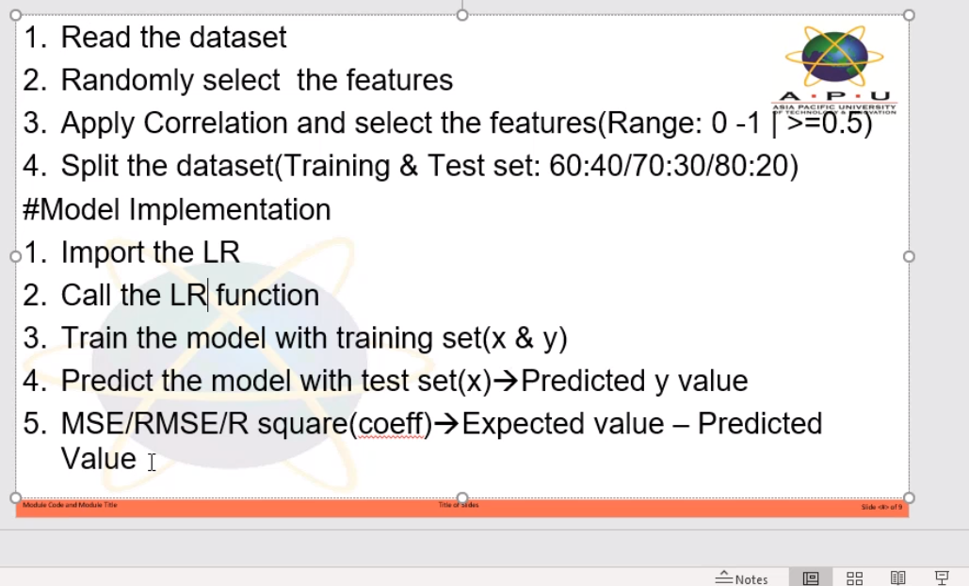

Pick correct x values to reduce error rate. Do this by applying correlation. Use pearson function to find relationship between input and output. To pick closely relevant x value to the y value.

What you’re classifying based on is the y value.

e.g, classification of classes. Dataset has name, age, country, gender, tp. Y value is gender, x values are the rest.

Use corr.dataset() function to check relationship btwn x values and y value.

